# Full Stack Development with MERN

## Project Documentation

## I. Introduction

• **Project Title:** Freelancing Application MERN

• **Team Members:**

- Sabarish T K – Project Manager & Testing: Responsible for testing, overseeing the entire project, ensuring timelines are met, and leading the team.

- Sabith Ahamed S – Database Administrator: Manages and optimizes the database, ensuring data integrity and efficient querying.

- Suresh L – Backend Developer: In charge of designing and implementing the server-side logic, APIs, and database interactions.

- Santhosh Kumar R – Frontend Developer: Develops and styles the user interface, ensuring a seamless and responsive user experience.

## II. Project Overview

• **Purpose:** Work Hive is a freelancing platform that connects clients with skilled freelancers. It offers an intuitive interface for project posting, bidding, and streamlined collaboration. With a dedicated admin team ensuring security and smooth communication, Work Hive aims to be the go-to platform for both clients and freelancers.

• **Features:**

- **Property Listing & Management:** Users can add, edit, and delete property listings.

- **User Registration & Login:** Secure authentication for property owners, renters, and administrators.

- **Search & Filter Options:** Users can filter properties by location, price range, property type, etc.

- **Booking System:** Renters can book properties and view their booking status.

- **Admin Panel:** Admins can manage user accounts and oversee bookings and listings.

- **Responsive UI:** Optimized for use on various devices, including desktops, tablets, and smartphones.

## III. Architecture

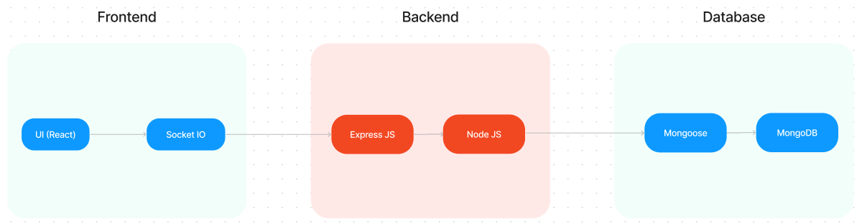

• **Frontend:**

- Developed using React, the app utilizes functional components and React Hooks for state management.

- The design is component-based, making it scalable and easy to maintain. React-Bootstrap is used for a sleek and responsive UI design.

• **Backend:**

- The server is built with Node.js and Express.js. It handles CRUD operations, user authentication, and integrates with a MongoDB database.

- RESTful API structure is implemented for clean and efficient communication between the frontend and backend.

• **Database:**

- MongoDB is used as the database. The schema is designed using Mongoose to handle data efficiently, with collections for users, applications, chats, freelancers and projects.

## IV. Setup Instructions

MongoDB, React.js:

✔**Node.js and npm:**

Node.js is a powerful JavaScript runtime environment that allows you to run JavaScript code on the server-side. It provides a scalable and efficient platform for building network applications.

Install Node.js and npm on your development machine, as they are required to run JavaScript on the server-side.

Download: https://nodejs.org/en/download/

Installation instructions: <https://nodejs.org/en/download/package-manager/>

✔**Express.js:**

Express.js is a fast and minimalist web application framework for Node.js. It simplifies the process of creating robust APIs and web applications, offering features like routing, middleware support, and modular architecture.

Install Express.js, a web application framework for Node.js, which handles server-side routing, middleware, and API development.

Installation: Open your command prompt or terminal and run the following command:

**npm install express**

✔**MongoDB:**

MongoDB is a flexible and scalable NoSQL database that stores data in a JSON-like format. It provides high performance, horizontal scalability, and seamless integration with Node.js, making it ideal for handling large amounts of structured and unstructured data.

Set up a MongoDB database to store your application's data.

Download: https://www.mongodb.com/try/download/community

Installation instructions: <https://docs.mongodb.com/manual/installation/>

✔**React.js:**

React.js is a popular JavaScript library for building user interfaces. It enables developers to create interactive and reusable UI components, making it easier to build dynamic and responsive web applications.

Install React.js, a JavaScript library for building user interfaces.

Follow the installation guide: <https://reactjs.org/docs/create-a-new-react-app.html>

✔**HTML, CSS, and JavaScript**: Basic knowledge of HTML for creating the structure of your app, CSS for styling, and JavaScript for client-side interactivity is essential.

✔**Database Connectivity**: Use a MongoDB driver or an Object-Document Mapping (ODM) library like Mongoose to connect your Express Js server with the MongoDB database and perform CRUD (Create, Read, Update, Delete) operations

✔**Front-end Framework**: Utilize React Js to build the user-facing part of the application, including entering booking room, status of the booking, and user interfaces for the admin dashboard. For making better UI we have also used some libraries like material UI and bootstrap.

✔**Version Control**: Use Git for version control, enabling collaboration and tracking changes throughout the development process. Platforms like GitHub or Bitbucket can host your repository.

Git: Download and installation instructions can be found at: https://git-scm.com/downloads

✔**Development Environment**: Choose a code editor or Integrated Development Environment (IDE) that suits your preferences, such as Visual Studio Code, Sublime Text, or WebStorm.

• Visual Studio Code: Download from <https://code.visualstudio.com/download>

## V. Folder Structure

• **Frontend:**

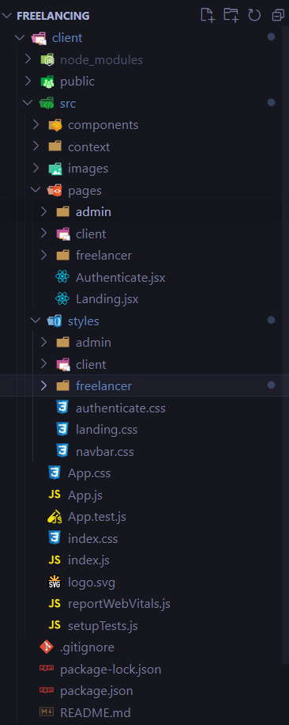

• **Backend:**

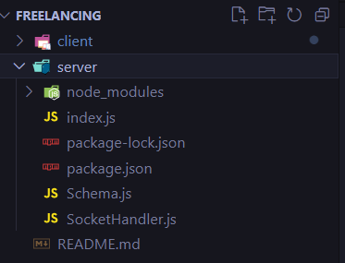

## VI. Running the Application

1. Clone the repository:

git clone <https://github.com/sbrsh-2424/Freelancing>

1. Navigate to the project directory:

cd client

cd server

3. Install dependencies for both frontend and backend:

- For client:

npm install

- For server:

node index.js

4. Set up environment variables:

- Create a .env file in the server directory and define variables such as MongoDB URI, JWT Key & Port number.

• Access the app at: <http://localhost:3000>

## VII. API Documentation

**Base URL: http://localhost:6001**

**Authentication Routes**

**1. Register a User**

**Method**: POST

**Endpoint**: /register

**Purpose**: Registers a new user (freelancer or client).

**Request Body**:

{

"username": "JohnDoe",

"email": "johndoe@example.com",

"password": "securepassword123",

"usertype": "freelancer" // or "client"

}

**Response**:

{

"_id": "user_id_here",

"username": "JohnDoe",

"email": "johndoe@example.com",

"usertype": "freelancer"

}

**2. Login a User**

**Method**: POST

**Endpoint**: /login

**Purpose**: Authenticates a user.

**Request Body**:

{

"email": "johndoe@example.com",

"password": "securepassword123"

}

**Response**:

{

"_id": "user_id_here",

"username": "JohnDoe",

"email": "johndoe@example.com",

"usertype": "freelancer"

}

**Freelancer Routes**

**3. Fetch Freelancer by ID**

**Method**: GET

**Endpoint**: /fetch-freelancer/:id

**Purpose**: Fetches freelancer details using the user ID.

**Response**:

{

"_id": "freelancer_id_here",

"userId": "user_id_here",

"skills": ["React", "Node.js"],

"description": "Experienced developer"

}

**4. Update Freelancer Information**

**Method**: POST

**Endpoint**: /update-freelancer

**Purpose**: Updates freelancer skills and description.

**Request Body**:

{

"freelancerId": "freelancer_id_here",

"updateSkills": "React,Node.js",

"description": "Updated description"

}

**Project Routes**

**5. Fetch Project by ID**

**Method**: GET

**Endpoint**: /fetch-project/:id

**Purpose**: Fetches a project by its ID.

**Response**:

{

"_id": "project_id_here",

"title": "Project Title",

"description": "Project description",

"budget": 1000,

"skills": ["React", "Node.js"],

"clientId": "client_id_here"

}

**6. Fetch All Projects**

**Method**: GET

**Endpoint**: /fetch-projects

**Purpose**: Retrieves all projects.

**Response**:

[

{

"_id": "project_id_1",

"title": "Project 1",

"description": "Description 1"

},

{

"_id": "project_id_2",

"title": "Project 2",

"description": "Description 2"

}

]

**7. Create a New Project**

**Method**: POST

**Endpoint**: /new-project

**Purpose**: Adds a new project.

**Request Body**:

{

"title": "Project Title",

"description": "Project description",

"budget": 1000,

"skills": "React,Node.js",

"clientId": "client_id_here",

"clientName": "Client Name",

"clientEmail": "client@example.com"

}

**Response**:

{

"message": "Project added"

}

**Bid and Application Routes**

**8. Make a Bid**

**Method**: POST

**Endpoint**: /make-bid

**Purpose**: Submits a bid for a project.

**Request Body**:

{

"clientId": "client_id_here",

"freelancerId": "freelancer_id_here",

"projectId": "project_id_here",

"proposal": "Proposal details",

"bidAmount": 500,

"estimatedTime": "7 days"

}

**Response**:

{

"message": "Bidding successful"

}

**9. Fetch All Applications**

**Method**: GET

**Endpoint**: /fetch-applications

**Purpose**: Fetches all project applications.

**Response**:

[

{

"_id": "application_id_1",

"projectId": "project_id_1",

"freelancerId": "freelancer_id_1",

"status": "Pending"

}

]

**10. Approve an Application**

**Method**: GET

**Endpoint**: /approve-application/:id

**Purpose**: Approves a project application and assigns it to the freelancer.

**11. Reject an Application**

**Method**: GET

**Endpoint**: /reject-application/:id

**Purpose**: Rejects a project application.

**Submission Routes**

**12. Submit a Project**

**Method**: POST

**Endpoint**: /submit-project

**Purpose**: Submits the completed project by a freelancer.

**Request Body**:

{

"clientId": "client_id_here",

"freelancerId": "freelancer_id_here",

"projectId": "project_id_here",

"projectLink": "http://project-link.com",

"manualLink": "http://manual-link.com",

"submissionDescription": "Details of the submission"

}

**Response**:

{

"message": "Project added"

}

**13. Approve Submission**

**Method**: GET

**Endpoint**: /approve-submission/:id

**Purpose**: Marks a submitted project as "Completed."

**14. Reject Submission**

**Method**: GET

**Endpoint**: /reject-submission/:id

**Purpose**: Rejects a submitted project.

**Chat Routes**

**15. Fetch Chats by ID**

**Method**: GET

**Endpoint**: /fetch-chats/:id

**Purpose**: Fetches chat messages using chat ID.

**Response**:

{

"_id": "chat_id_here",

"messages": [

{ "sender": "user_id_1", "message": "Hello!" }

]

}

**User Management**

**16. Fetch All Users**

**Method**: GET

**Endpoint**: /fetch-users

**Purpose**: Retrieves a list of all registered users.

## XII. Authentication

• Token-based Authentication:

- Upon successful login, users receive a JSON Web Token (JWT), which is stored in local storage.

- Protected routes on the backend require a valid token, verified using middleware.

## XIII. User Interface

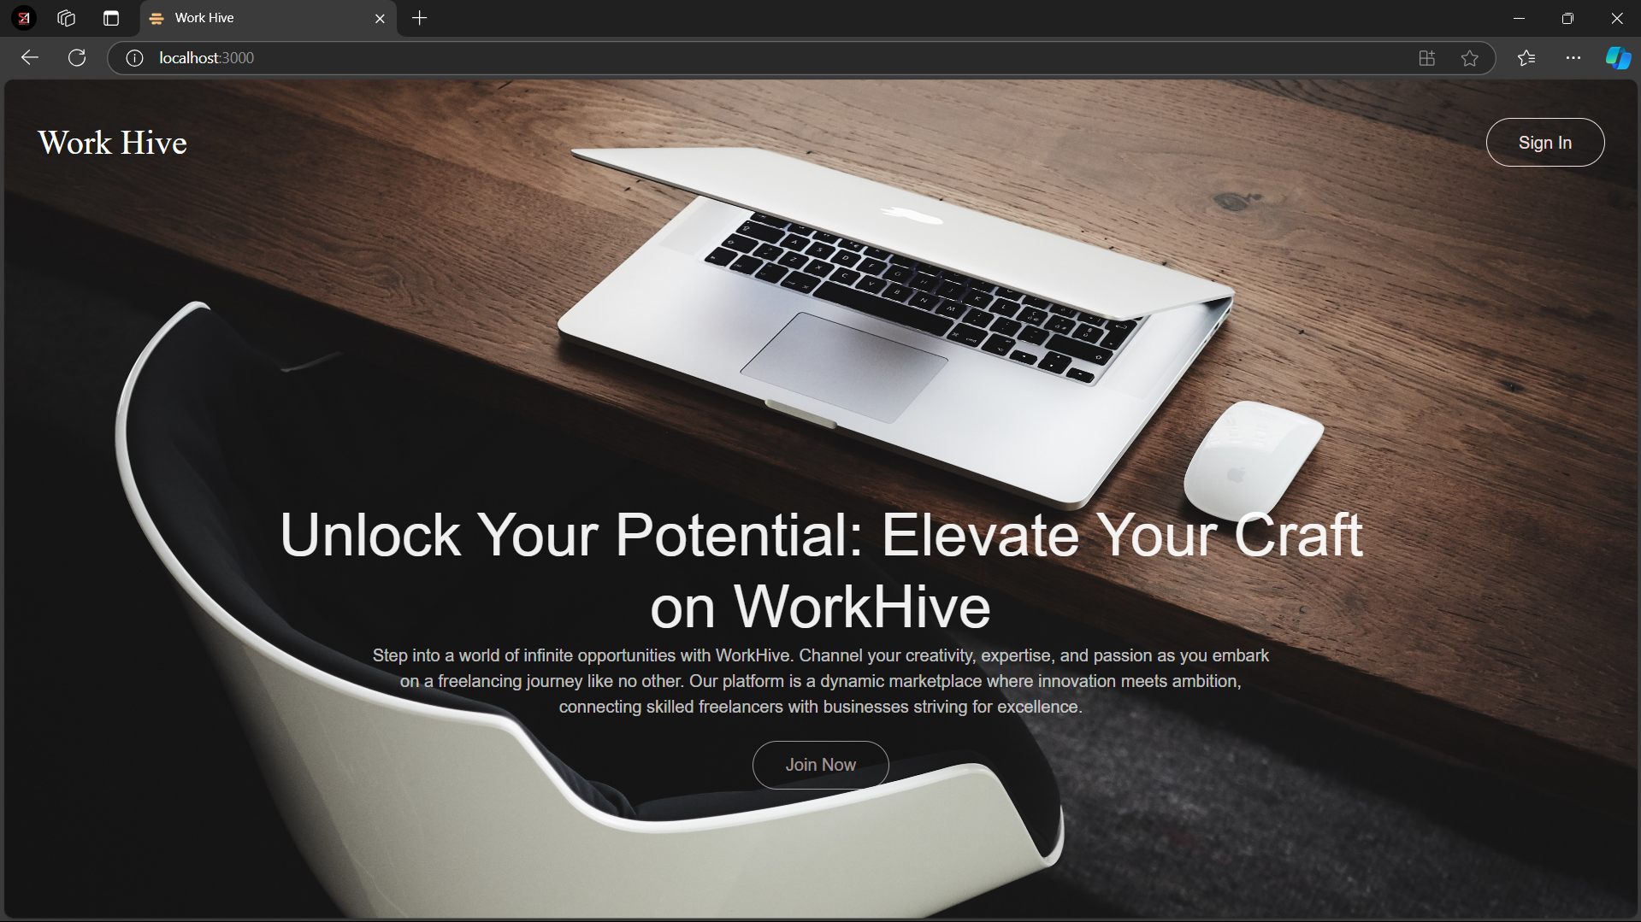

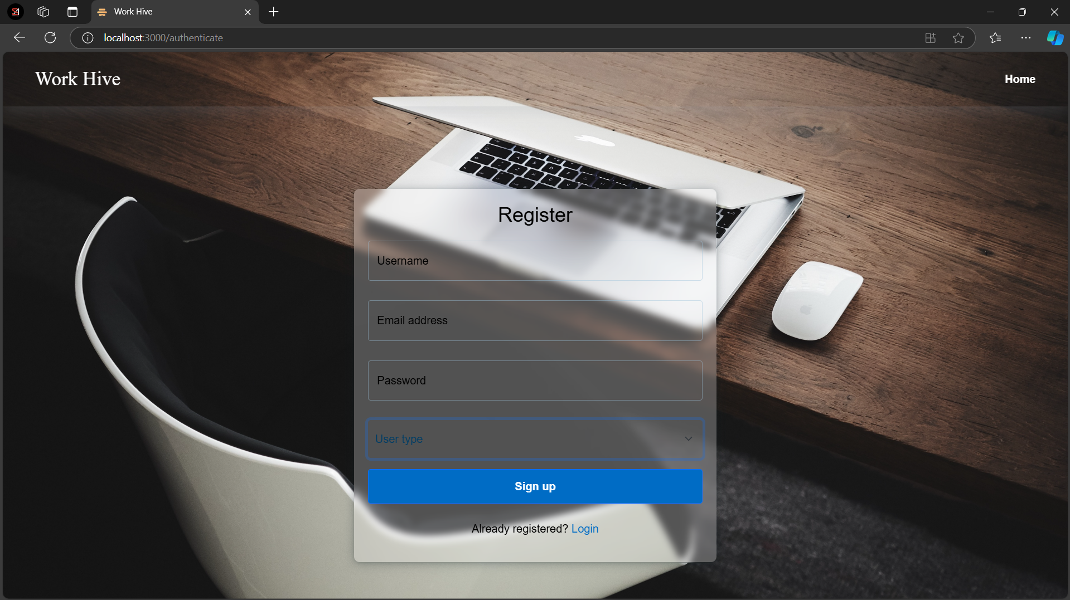

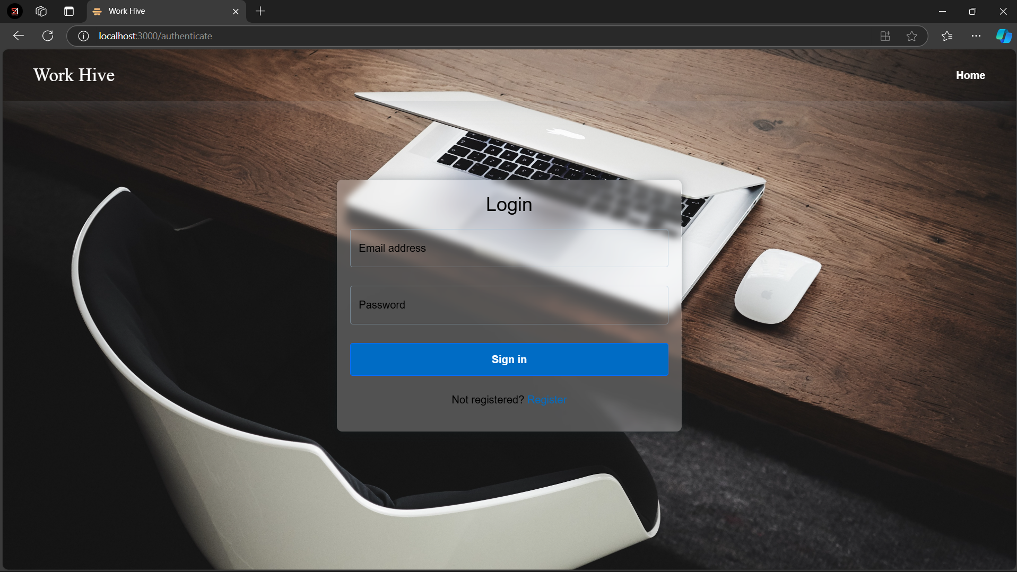

Freelancer Pages;

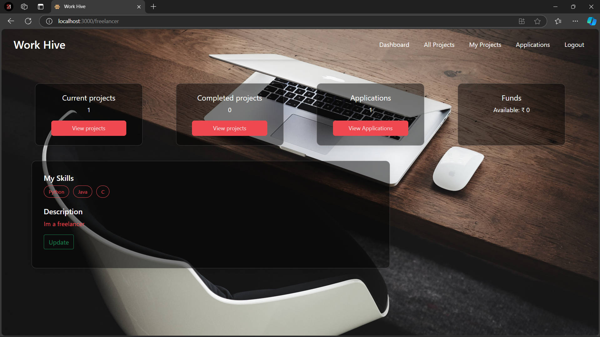

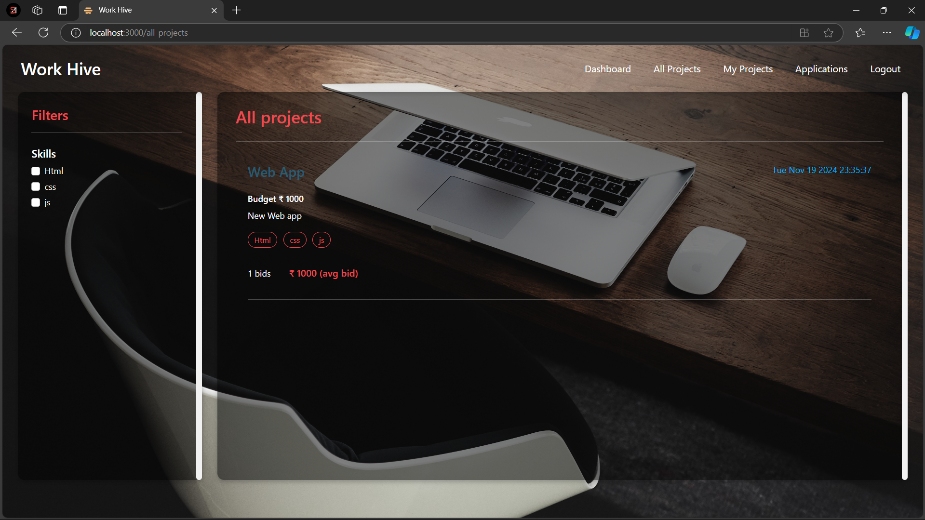

Client Pages:

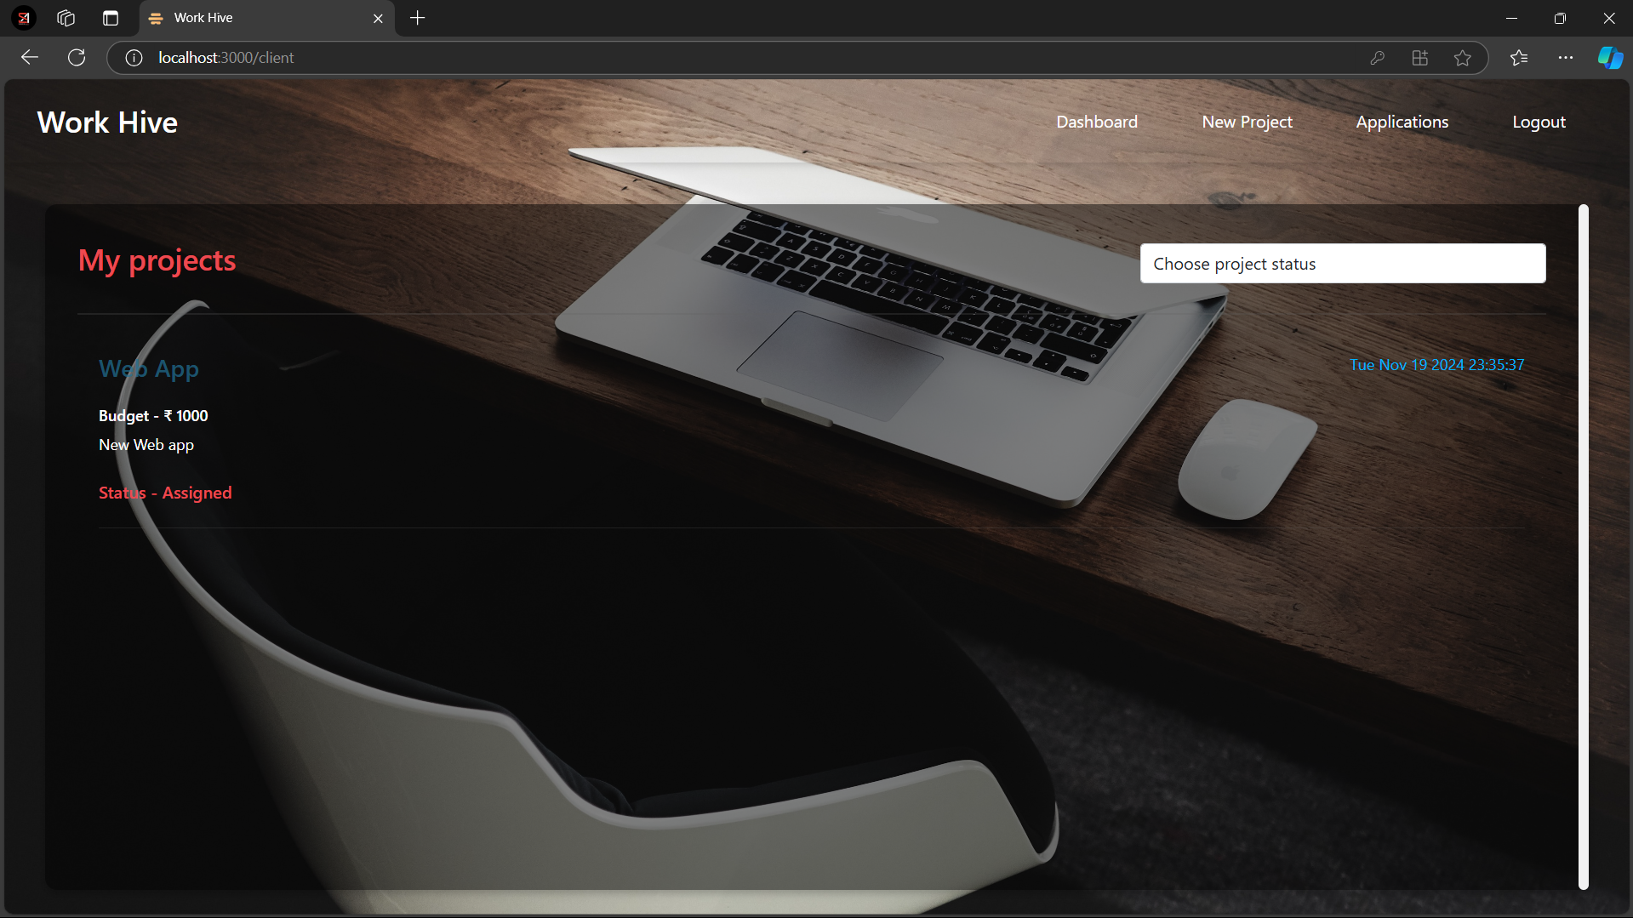

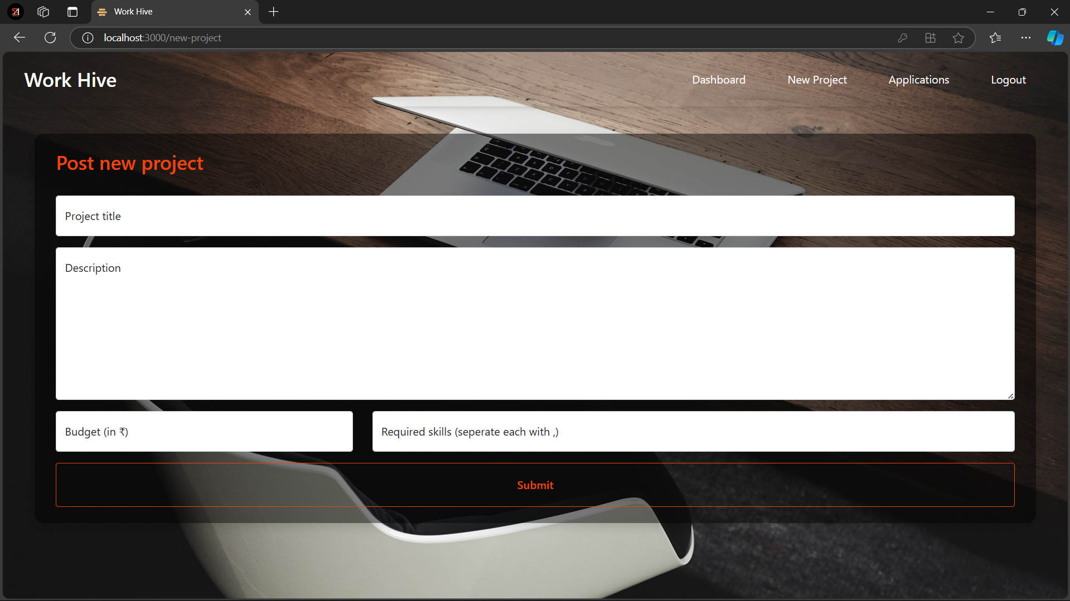

Admin Pages:

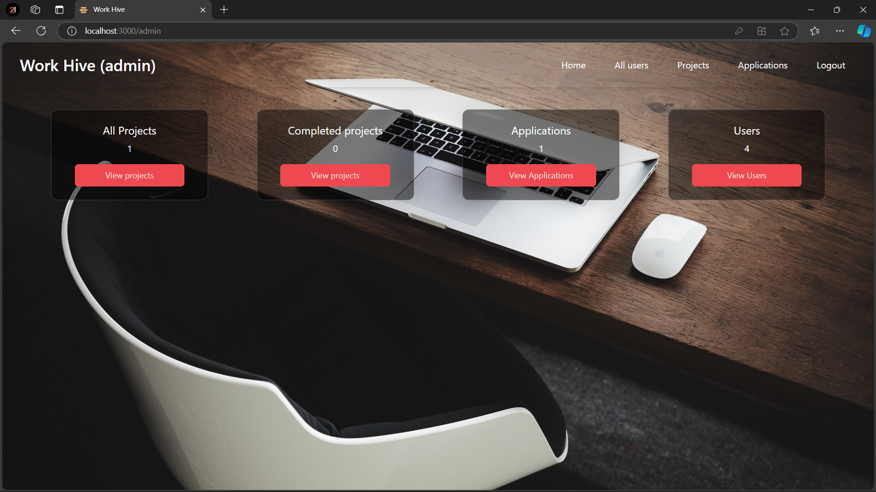

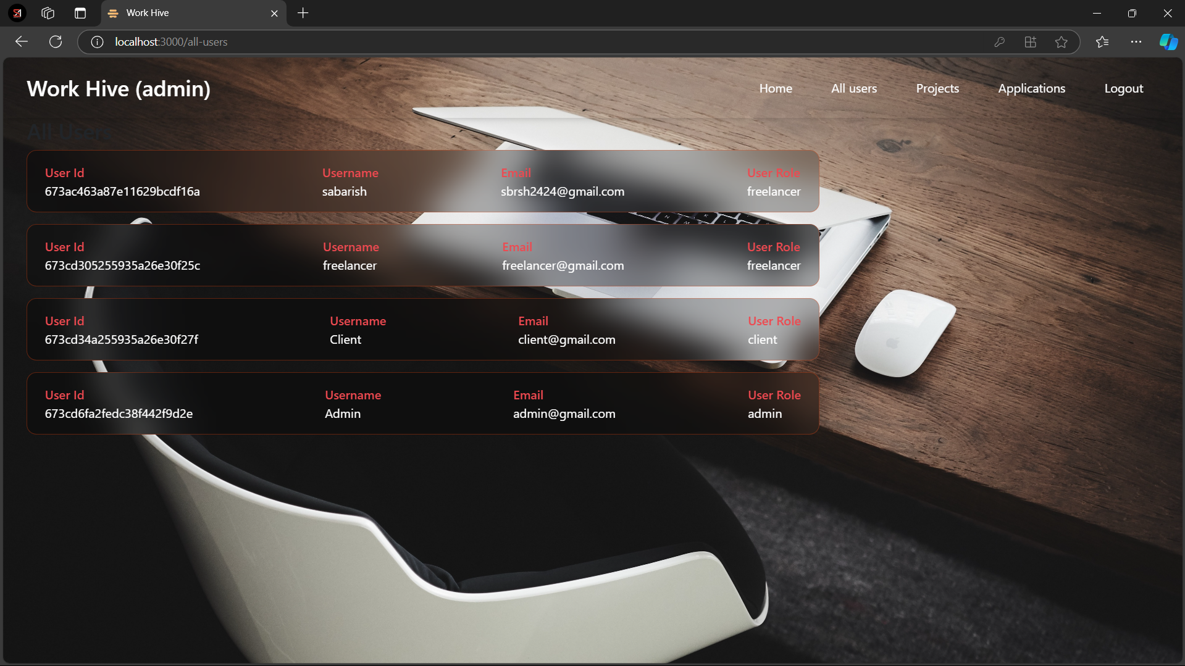

## XIV. Testing

• Testing: Unit and integration tests are implemented using tools like Jest for the frontend and Mocha for the backend.

## XV. Screenshots or Demo

## XVI. Known Issues

• **Finding Reliable Work**

* Freelancers can easily find legitimate projects to work on.

• **Clear Communication**

* Clients and freelancers can chat directly to discuss project details.

• **Managing Projects**

* Both parties can track project status, submissions, and payments in one place.

## XVII. Future Enhancements

• **In-App Payment System**

* Secure, reliable, and seamless payment options for clients and freelancers to ensure smooth financial transactions.

• **Advanced Matching Algorithm**

* AI-powered algorithm to better match freelancers with projects based on their skills, experience, and past performance.

• **Review and Rating System**

* A feedback system for both clients and freelancers to rate and review each other, building trust and transparency within the platform.